**Design of an Optimal Network for the University of Lahore Campus**



**Semester Project Report**

**Subject Name: Computer Communication & Networks**

**Submitted by**

**Ahamed Najah 70141084**

**M N M Nuzky 70141107**

**K F M Fazeen Shahfan 70141328**

**Supervised by**

Engr. Abeera

**Department of Computer Engineering**

**The University of Lahore**

**May,2024**

**Certificate of Approval**

The project entitled “**Design of an Optimal Network for the UOL Campus”** is hereby approved as Fifth semester Computer Communication & Networks project.

**Approved by:**

________________________________

Engr. Abeera

Project Supervisor,

Department of Computer Engineering,

The University of Lahore, Lahore

___________________________________

**Engr. Prof. Waseem**,

Head,

Department of Computer Engineering,

The University of Lahore, Lahore.

**Dedication**

This project is dedicated to my parents who stood by me and supported me in this journey

**Acknowledgments**

We express our sincere gratitude to all those people who have been associated with this project and have helped us with it and made it a worthwhile experience. We would like to thank our supervisor,Engr. Abeera for her direction, assistance, and guidance. Her recommendations and suggestions have been invaluable for the project. We are also thankful to **Engr. Dr Waseem**, Head of Department, and our teachers for continuous guidance and encouragement. We are also thankful to our families and friends for their encouragement and support.

**Table of Contents**

|  |  |  |
| --- | --- | --- |
| **Sr No.** | **Contents** | **Page No.** |
| 01 | **Certificate of Approval** | 02 |
| 02 | **Declaration** | 02 |
| 03 | **Dedication** | 03 |
| 04 | **Acknowledgments** | 04 |
| 05 | **List of Figures** | 06 |
| 06 | **List of Abbreviations** | 07 |
| 07 | **List of Tables** | 07 |
| 08 | **Abstract** | 08 |
| 09 | **Chapter 1: Introduction** | 09 |
| 10 | 1.1: Problem statement  1.2: Aims and objectives  1.3: Expected outcomes and application  1.4: Estimated budget  1.5 Gantt Chart | 09  09  10  10  11 |
| 11 | **Chapter 2: Literature Review** | 11 |
| 12 | **Chapter 3: Methodology & Block Diagram** | 12 |
|  | 3.1: Methodology | 12 |
| 13 | 3.2: Block diagram | 12 |
| 14 | **Chapter 4: Testing of Software** | 13 |
| 15 | **Chapter 5: Integration of Components and Results** | 17 |
| 16 | **Chapter 6: Conclusions and Future Work** | 18 |
| 17 | **References** | 19 |

**List of Figures**

|  |  |  |
| --- | --- | --- |
| **Figure No.** | **Description** | **Page No.** |
| 1.1 | The log of UOL | 01 |
| 3.1 | Block diagram | 12 |
| 4.1 | Departments | 13 |
| 4.2 | Other Offices | 14 |
| 4.3 | Admin office CLI | 14 |
| 4.4 | Dep-1 CLI | 15 |
| 4.5 | Dep-2 CLI | 15 |
| 4.6 | Dep-3 CLI | 15 |
| 4.7 | Dep-4 CLI | 15 |
| 4.8 | Library CLI | 16 |
| 4.9 | Other Office-1 CLI | 16 |
| 4.10 | Other Office-2 CLI | 16 |
| 4.11 | UOL Router CLI | 16 |

**List of Abbreviations**

|  |  |
| --- | --- |
| **Abbreviation** | **Full Form** |
| GMM | Gaussian Mixture Models |
| PCM | Pulse Code Modulation |
| IEA | Interactive Electronic Agent |
| MFFC | Mel-Frequency Cepstral Coefficients |
| UOL | University of Lahore |
| VLAN | Virtual Local Area Network |
| CLI | Command Line Interface |
| IOT | Internet of Things |

List of Tables

|  |  |  |
| --- | --- | --- |
| **Table No.** | **Description** | **Page No.** |
| 1.1 | Gantt chart | 10 |
|  |  |  |

**Abstract**

This project aims to design and implement an optimal wired network infrastructure for The University of Lahore campus, addressing current connectivity challenges. With four teaching engineering departments, a library, an admin block, and various offices relying on seamless communication, the proposed solution will leverage a 50 Mbps fiber optic connection to establish a scalable, efficient, and reliable network. Key features include automated IP configuration using DHCP, fair bandwidth management strategies, and an environmentally sustainable design. By analyzing campus requirements, implementing a robust network topology, and integrating state-of-the-art networking components, this initiative will enhance productivity, data integrity, and user experience. The outcome will not only improve current connectivity but also support future growth, aligning with the university's mission of fostering a digitally advanced academic environment.

**Introduction**

## 1.1 Problem statement

The University of Lahore faces several challenges in providing a robust network infrastructure for its campus. The existing setup lacks efficient wired connectivity across the teaching engineering departments, Library, Admin block, and other offices. Additionally, the absence of proper bandwidth management strategies leads to unfair resource allocation, impacting productivity. There is also no automated system in place for IP configuration, resulting in inefficiencies and potential errors. This project aims to address these challenges by designing a scalable and efficient network solution tailored to the specific needs of the campus.

## 1.2 Aims and objectives

* **Project Objectives:**

List the primary goals of your project:

1. To design a robust network topology that ensures optimal wired connectivity.
2. To implement automated IP configuration using DHCP for all users.
3. To manage bandwidth efficiently and ensure fair usage across all systems.
4. To assess the societal and environmental impact of the proposed solution.

* **Project Tasks:**
* **Planning Phase:**

Conduct a **requirement analysis** to determine the connectivity needs of all departments, offices, and libraries. Identify the current network challenges, such as bandwidth bottlenecks, IP conflicts, and limited scalability. Research and select appropriate networking hardware, such as routers, switches, and cables, considering budget constraints.

* **Network Design Phase:**

Develop a **comprehensive network topology** that ensures scalability and efficiency. Design subnetting schemes to optimize IP address allocation across departments. Choose appropriate bandwidth allocation strategies to ensure fair usage for all users. Prepare a block diagram to visually represent the core components and connections.

* **Hardware and Software Configuration:**

Procure and set up required hardware, including switches, routers, and access points. Configure devices for core functionalities such as DHCP, VLANs, and routing protocols. Establish and test connectivity between all components to ensure functionality.

* **Testing and Troubleshooting:**

Perform individual and integrated system testing to ensure:

* + Fair bandwidth distribution.
  + Seamless IP address assignment using DHCP.
  + Connectivity across all departments, offices, and the library.

Troubleshoot and resolve issues such as packet loss, latency, or hardware misconfigurations.

**1.3 Expected outcomes and applications**

The expected outcomes of this project include a reliable and fast wired network that provides seamless internet connectivity for all departments, offices, and the library at The University of Lahore. By implementing automatic IP configuration through DHCP, the network will be easier to manage, reducing errors and saving time. The proper allocation of bandwidth will ensure fair and efficient internet usage, avoiding slow speeds or overloading issues. The network will also be scalable, allowing it to grow as the university's needs increase, and energy-efficient devices will help reduce power consumption, aligning with eco-friendly practices. This improved network will greatly benefit students, teachers, and staff by enabling access to online classes, e-libraries, and collaborative tools. Administrative operations will also run more smoothly, enhancing communication and productivity across departments. For research activities, the high-speed internet will support large data transfers and advanced projects. Additionally, the network can integrate with campus security systems like surveillance cameras and access controls to ensure safety. In the future, it will serve as a foundation for implementing advanced technologies such as IoT devices and AI-based network management, supporting the university’s vision of a smart campus.

**1.4 Estimated budget**

Software project has no budget.

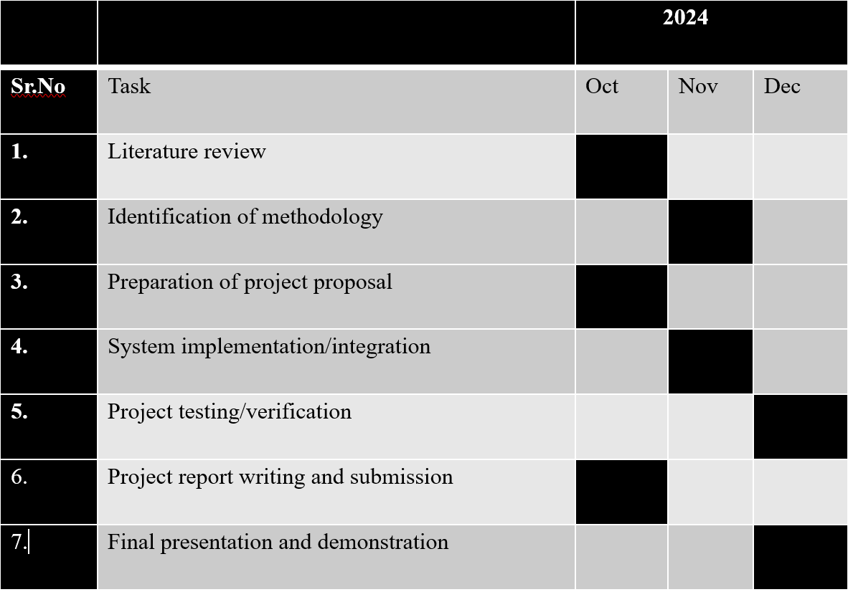**1.5 Gantt Chart**

**Table No 1.1: Gantt Chart**

**Chapter 2: Literature Review**

The design and implementation of an optimal network infrastructure have been extensively discussed in academic and industry literature. Studies emphasize the importance of scalable and efficient networks in academic institutions to support teaching, learning, and administrative tasks. [1] Cisco Networking Academy resources, (2011) provide practical insights into configuring switches, routers, and bandwidth management strategies for large-scale networks. [2] Research by Kumar et al. (2019) on "Efficient Network Design for Educational Institutions" underscores the need for bandwidth optimization and automated IP configuration to enhance user experience. [3] Gupta, R., & Sharma, P. (2021). "Advanced Networking Solutions for Universities" discuss the role of DHCP in automating IP assignment and ensuring consistent connectivity. [4] Ahmed, Z., & Khan, H. (2020). "Environmental Impacts of Network Implementations" provide insights into minimizing the carbon footprint of large-scale networks. [5] The work of Chen, L., & Zhang, Y. (2020), "IoT Integration in Educational Networks," explores the integration of IoT devices in modern campus networks, providing strategies for ensuring compatibility and data security. This literature forms the foundation for the proposed project, ensuring that the design leverages best practices and proven methodologies to address the specific needs of the University of Lahore.

**Chapter 3: Methodology & Block Diagram**

## 3.1Methodology

1. Phase 1: Network Requirements Analysis and Design:
   1. Conduct a detailed analysis of the campus network requirements, including the number of users, expected traffic, and hardware requirements.
   2. Define components such as switches, routers, access points, and cabling. Develop a comprehensive topology diagram considering scalability and efficiency.
2. Phase 2: Core Network Setup and Configuration:
   1. Implement the core network design by setting up switches, routers, and access points.
   2. Configure IP addressing and subnets, utilizing DHCP for automated IP assignment.
   3. Test individual components for proper functionality.
3. Phase 3: Final Integration, Testing, and Impact Assessment:
   1. Integrate all components into a cohesive network.
   2. Conduct comprehensive testing to ensure fair and optimal bandwidth usage.
   3. Assess societal and environmental impacts of the network design.

**3.2Block Diagram**

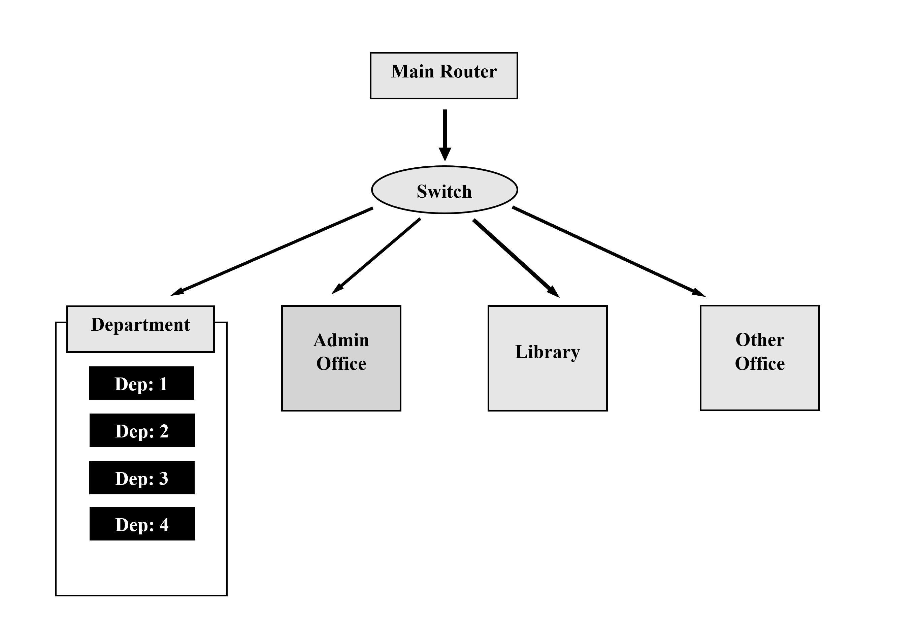

Figure 3.1: Project block diagram

**Chapter 4: Testing of Software**

To test the network, start by verifying that all devices within each VLAN can communicate with one another. For example, ensure that PCs and laptops in "Department 1" can exchange data without any issues using simple connectivity tests like the ping command. Then, check communication between different VLANs, such as from "Department 1" to the "Admin Office," through the Multilayer Switch to confirm inter-VLAN routing is working correctly. DHCP functionality must also be tested to ensure all devices are automatically assigned IP addresses from the correct subnet, like 192.168.1.0/24 for "Department 1."

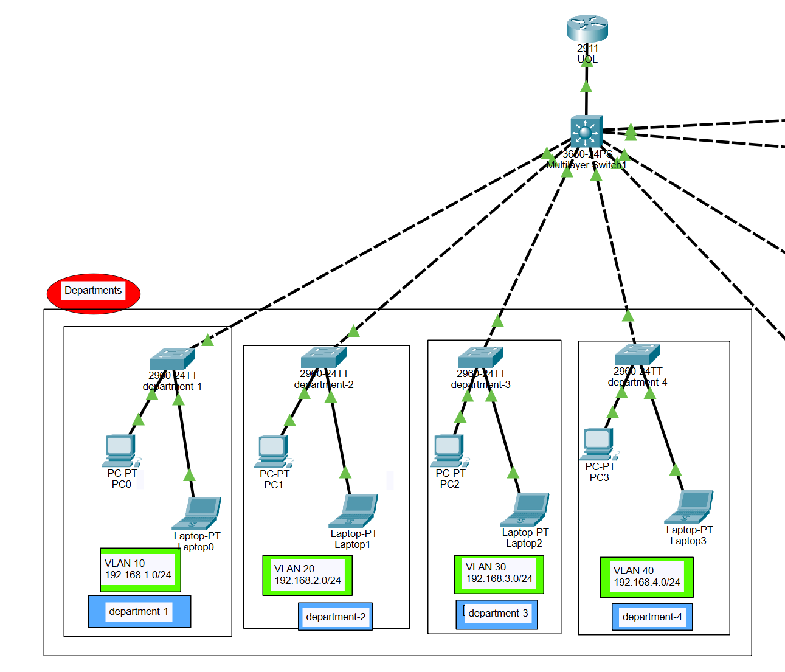

Figure 4.1 Departments

Next, simulate real-world traffic across the network to evaluate bandwidth performance and ensure fair resource allocation. Use tools like Wireshark or iPerf to monitor network speed and detect bottlenecks. Security is another critical aspect, so verify that access controls prevent unauthorized communication and confirm that VLAN isolation is functioning as expected. Finally, conduct practical tests such as file sharing or accessing shared drives to ensure seamless end-to-end connectivity throughout the network.

For the software, Cisco Packet Tracer is ideal for designing and simulating the network before actual deployment. Wireshark can help analyze traffic and troubleshoot issues, while iPerf measures network performance. Use Nmap to scan devices and test connectivity, and Putty or Tera Term to configure network devices via the command line. These tools will help ensure the network operates efficiently, securely, and as intended.

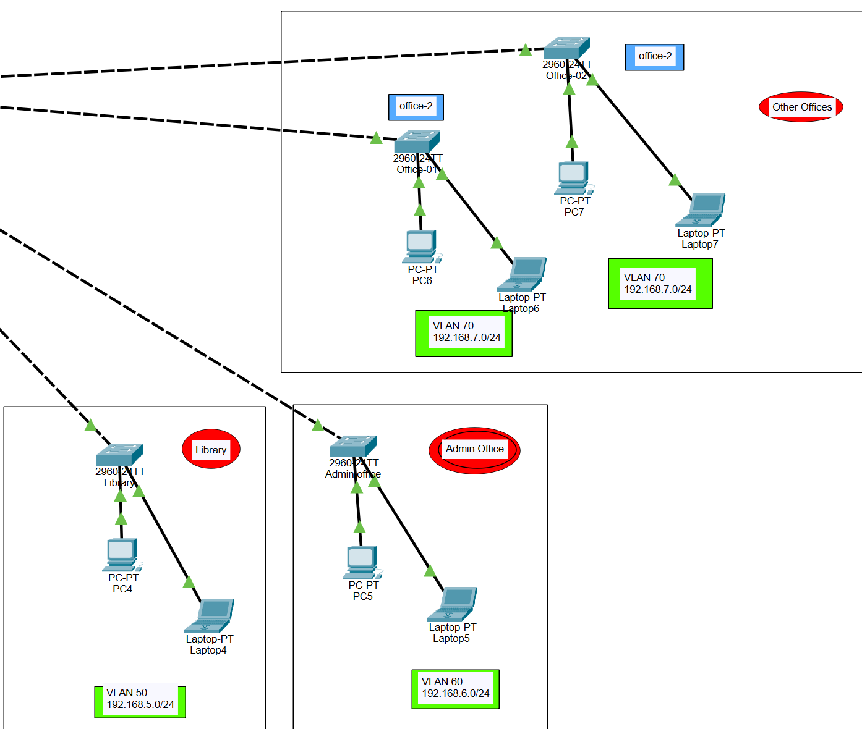

Figure 4.2 Other Offices

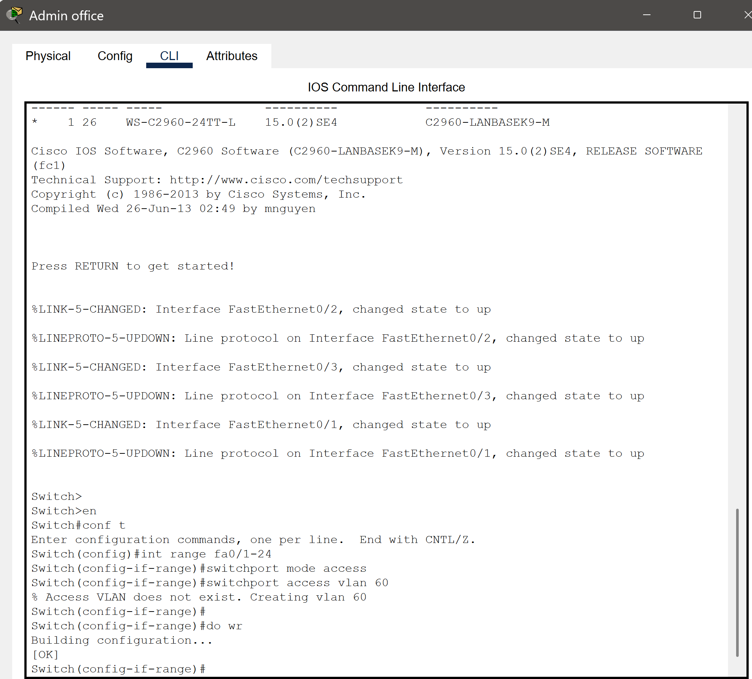

Figure 4.3 Admin office CLI

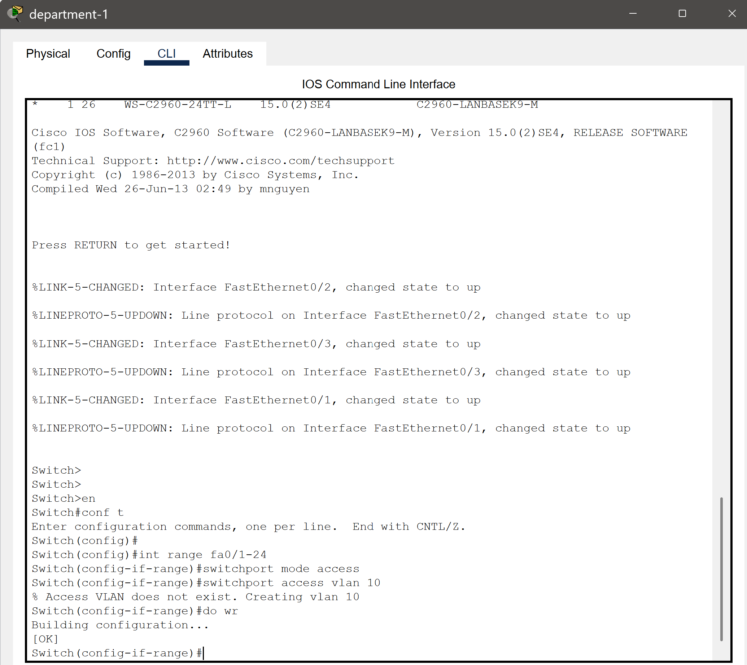

Figure 4.4 Dep-1 CLI

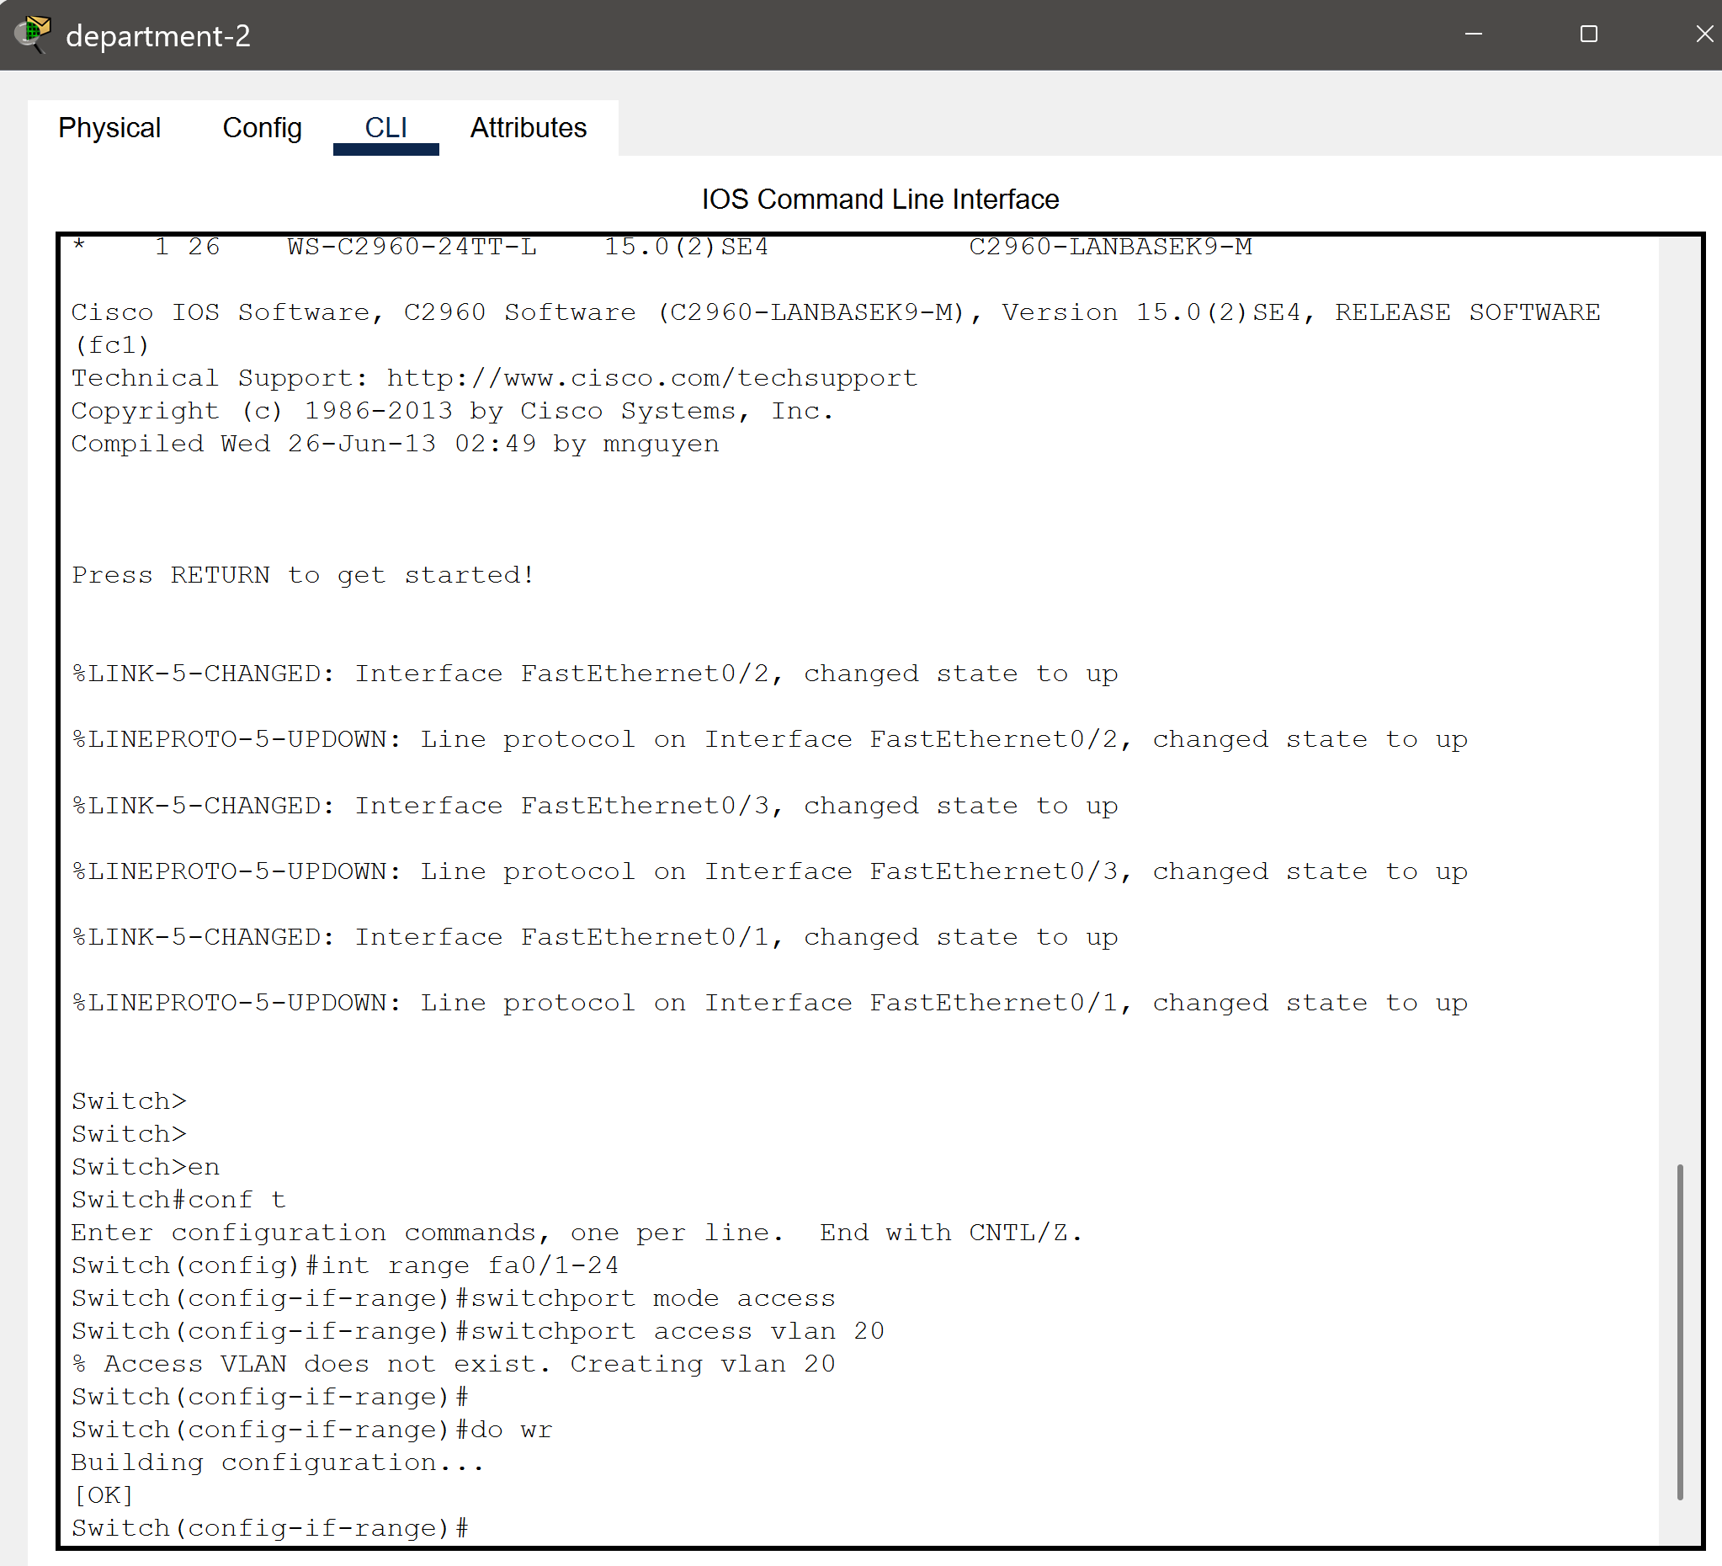

Figure 4.5 Dep-2 CLI

# 

Figure 4.6 Dep-3 CLI

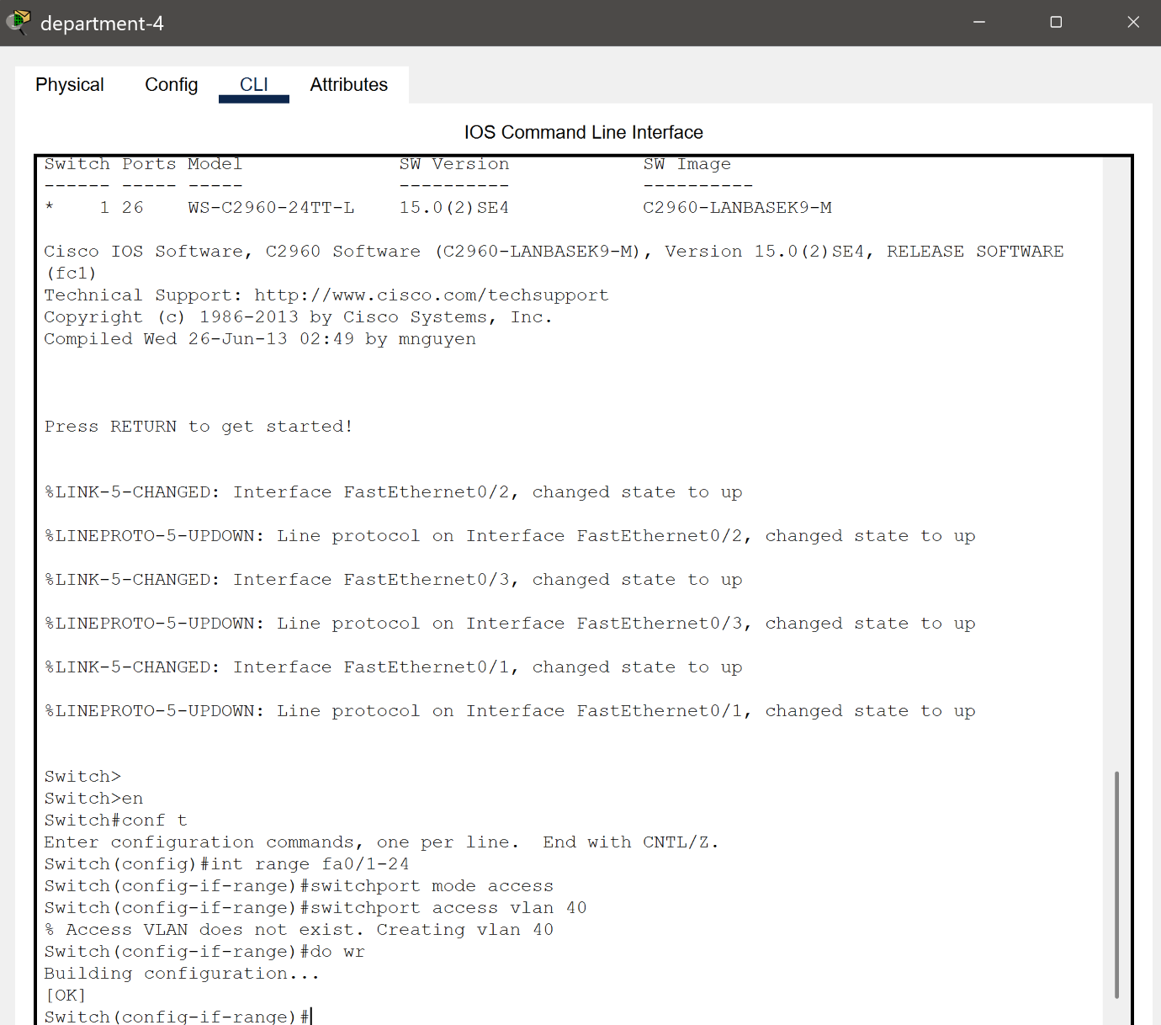

Figure 4.7 Dep-4 CLI

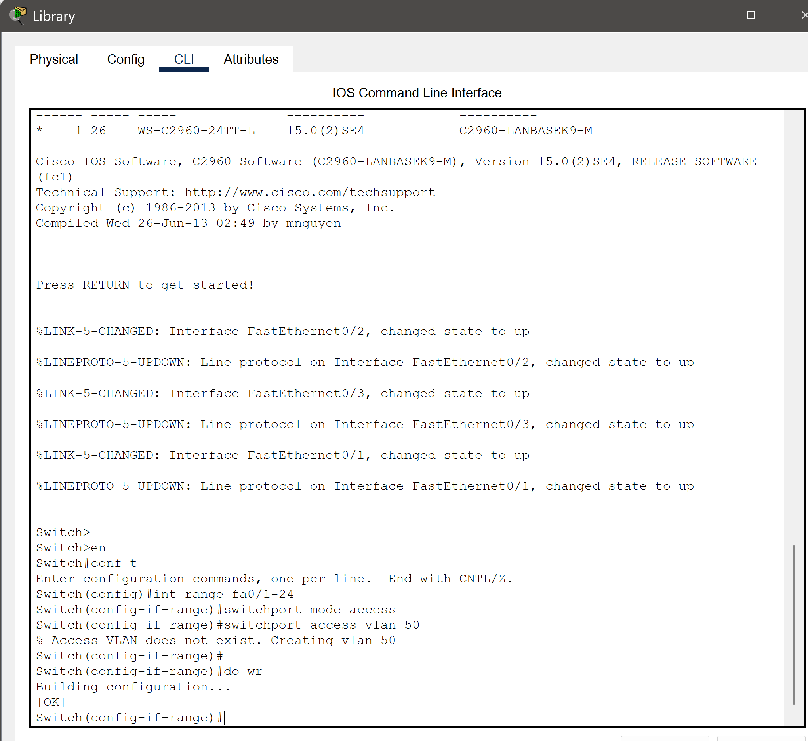

Figure 4.8 Library CLI

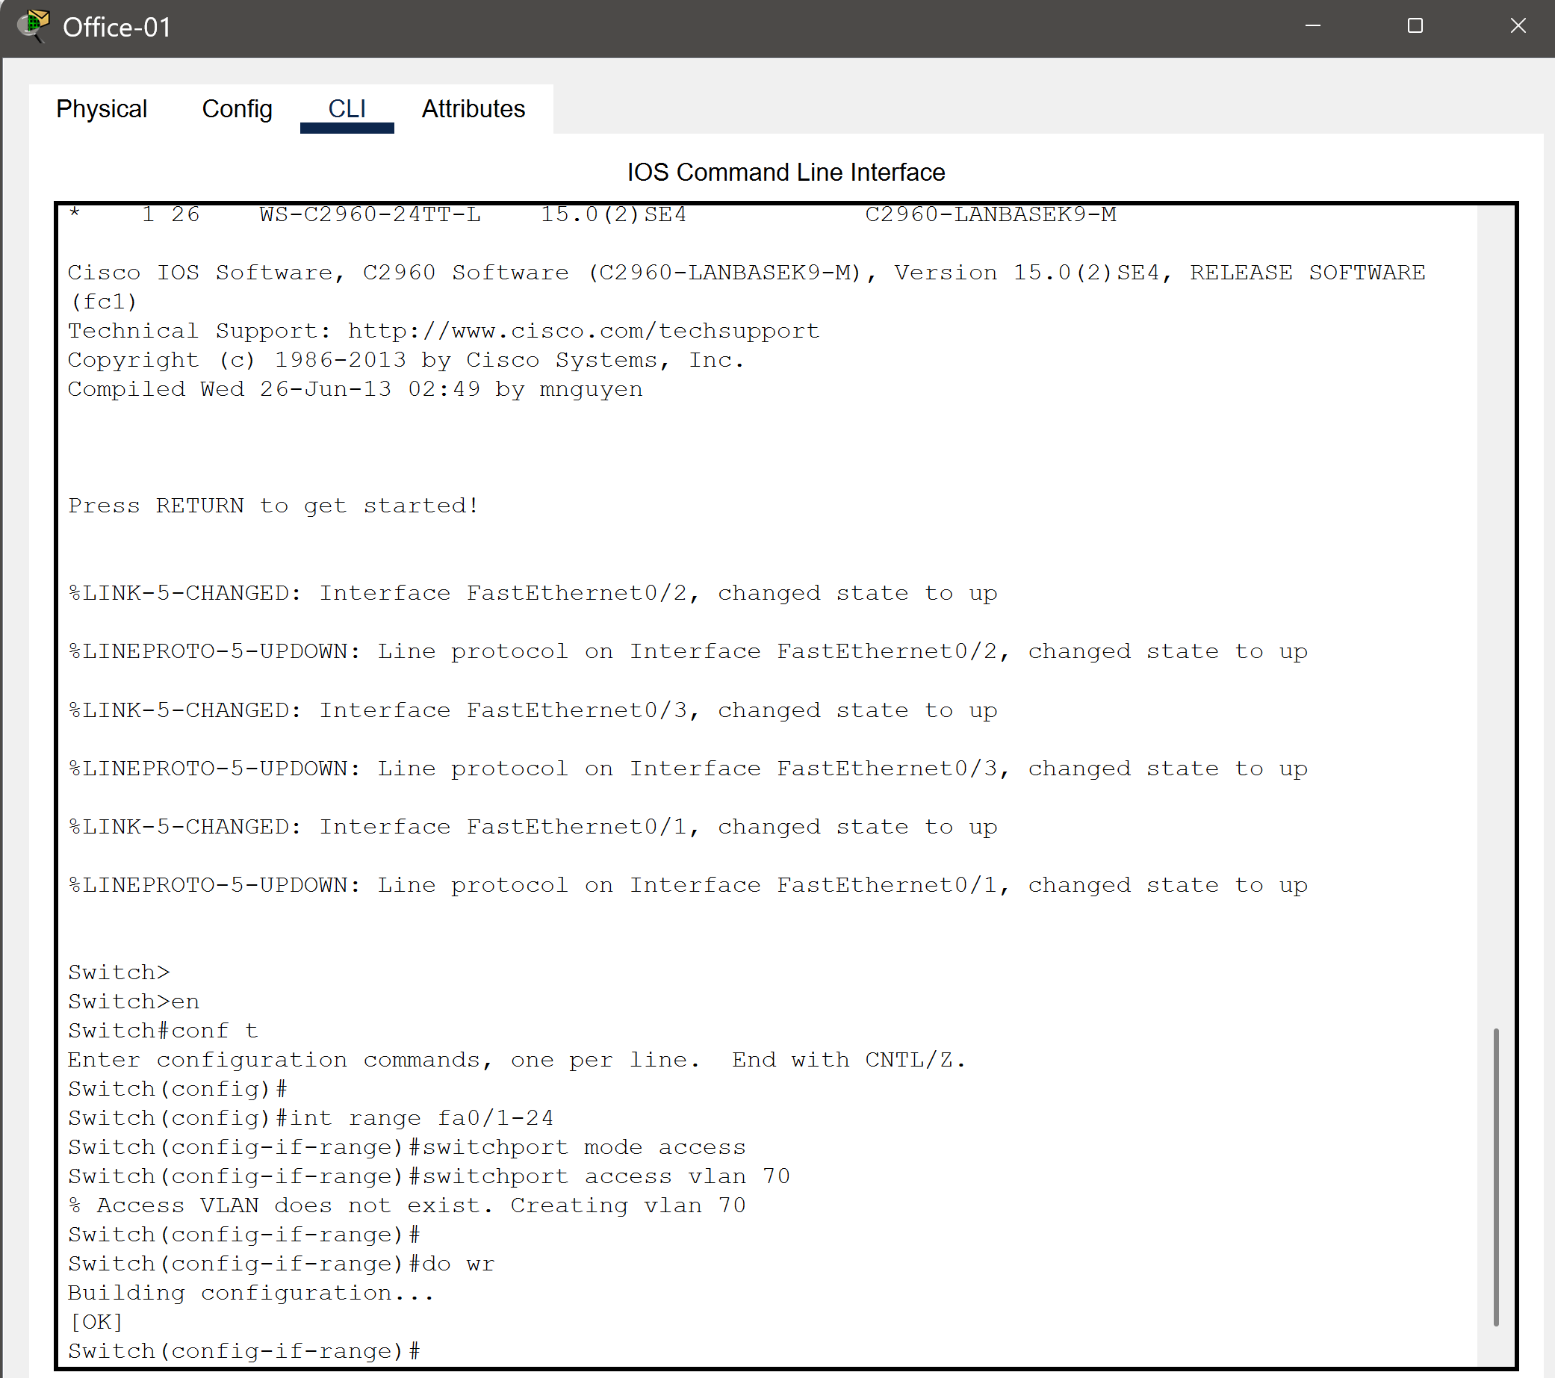

Figure 4.9 Other Office-01 CLI

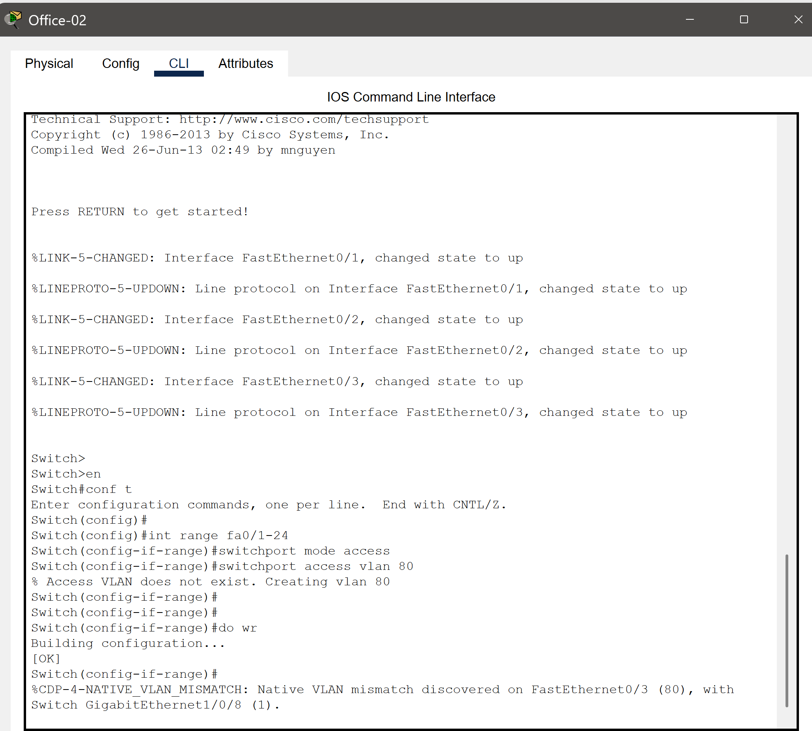

Figure 4.10 Other Office-02 CLI

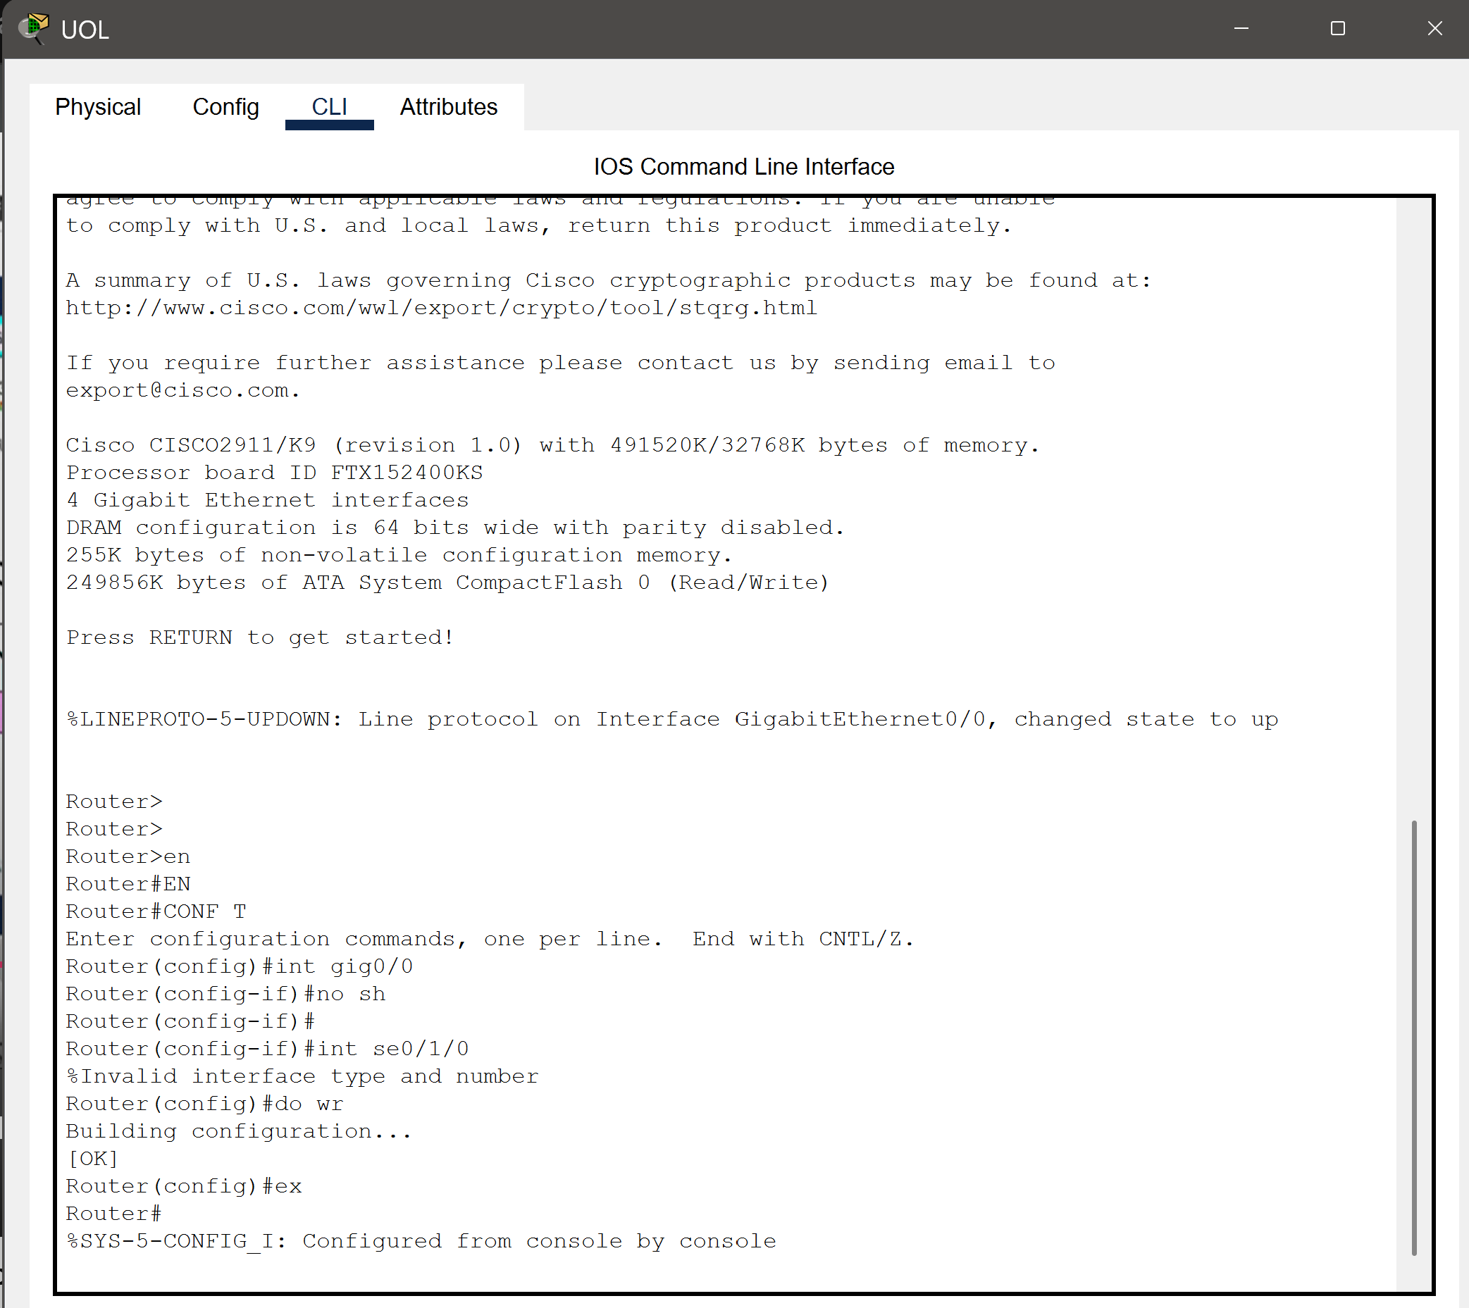

Figure 4.11 UOL Router CLI

### **Chapter 5: Integration of Components and Results**

Integrating the components of the network involves bringing together all the devices and configurations into a seamless system. The first step is to connect all the switches, routers, and end devices like PCs and laptops according to the designed topology. Once the physical connections are in place, the configurations for VLANs, DHCP, and inter-VLAN routing are applied to the switches and routers. Each component is tested individually to ensure proper functionality before integrating them into the larger network. The DHCP server is configured to assign IP addresses automatically, and its functionality is verified by checking whether all devices in the network receive the correct IP addresses for their respective VLANs. Routing between VLANs is enabled and tested to ensure smooth communication between different departments, the library, and offices. The overall bandwidth management is also configured to ensure fair usage across all devices, avoiding network congestion. As a result of this integration, the network becomes fully operational, with devices across the campus enjoying reliable connectivity. The system ensures efficient data flow, fair bandwidth distribution, and easy management through automated IP configuration. The successful integration also supports the university’s growth, allowing future scalability and the addition of advanced technologies like IoT devices. This enhanced network infrastructure will significantly improve productivity, collaboration, and resource accessibility for students, faculty, and administrative staff.

### **Chapter 6: Conclusions and Future Work**

In conclusion, the network design for The University of Lahore aims to provide a robust and scalable infrastructure to meet the increasing demands of connectivity across departments, the library, the admin office, and other sections. By implementing VLANs, DHCP for automated IP configuration, and efficient bandwidth management, the network ensures fair usage, seamless communication, and improved productivity for students, faculty, and staff. The design also emphasizes scalability, allowing the network to grow with the university's future needs, while energy-efficient practices contribute to sustainability. For future work, the network can be enhanced by integrating advanced technologies like IoT devices for smart classrooms and campus automation. Additionally, implementing AI-based network monitoring and management tools can further optimize performance and security. With these advancements, the university can continue to evolve into a fully connected and technology-driven academic environment.

# **References**

|  |  |
| --- | --- |
|  | 1. A. S. &. W. D. J. Tanenbaum, "Computer Networks," 2011. |
|  | 1. Kumar, "bandwidth optimizations & automated IP configuration," 2019. |
|  | 1. G. R. &. S. P, "Advance networking Solutions for the university," 2021. |
|  | 1. Z. A. &. H. khan, "Environmental impects of network implementations," 2020. |
|  | 1. Y. Z. &. L. Chen, IOT Itegration in Educatioanal Network, 2020. |